RSGB – Eco Business Driving website instructions

If you have any questions that you feel this ‘help’ page does not answer please email Ian Edwards at ian.edwards@edrivingsolutions.com

Website

http://rsgb.eco-businessdriving.co.uk is a database created to organise and record the attendance of different RSGB Courses. At the top of every page on the website there is a row of 9 tabs which, when clicked, take you to different areas of the site.

Below is a picture of the 9 button control panel:

This next section takes you through each of the tabs:

Corporate Members
‘Corporate members’ is the page you will be taken to after logging on to the site successfully.

This page’s main content consists of a table, which shows the councils, and authorities that are associated with `RSGB’.

The table consists of 7 headers:

- Name - name of the council.
- Region - where the council is located
- Last date invoiced - shows the date the last time the council was invoiced
- Last paid – the last date the council paid
- Paid up to – what date the council has paid up to
- Members – shows how many members the council has within the system
- Action – allows access to further details of the council by clicking on the magnifying glass icon, or to delete the row by clicking on the minus sign icon

Below is a picture of the table headers

Above the table there is a row of buttons that can be used to add a new corporate member, send an invoice to a council, find the details of a council within the table, or download information about a council. A picture of this can be found below:

Academy Members
The academy member’s page can be found by clicking on the 2nd button along the top row of options, titled ‘academy members’.

The main content of the page consists of a table with the name, email address, invoice and payment details and member status of every academy member within the system

Below is a picture of the table headers with 7 different headers

To add a new member, send an invoice or do a search of the table, use the command panel that can be found above the table

Below is a picture of the control panel

Applications
The 3rd tab along the control panel is titled ‘Applications’. This tab is where Academy Membership Applications are accepted or rejected.

Course Types
The 4th tab along the control panel is titled ‘course types’. This tab gives information about the various courses such as the price of a particular course for members and non-members. The information is displayed in a table.

Below is a picture of the table headers

A new type of course can be added to the table by clicking on the ‘Add a new course type’ button, which can be found above the table. After clicking this button you must enter the details of the course as instructed

Below is a picture of the ‘add a new course type’ button

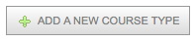

Trainers
The 5th tab along the control panel is titled ‘Trainers’. From this page you can see the details of the trainers. The information is displayed in a table

Below is a picture of the table headers

Below is a picture of the button used to add a new row to the table. Once you click on the user will be taken to a screen that requires the new trainer’s details, before adding them to the table

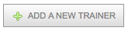

Coordinators
The 6th tab found along the website control panel is ‘Coordinators’. The coordinator is a person who organises a course for a local area on behalf of RSGB.

To add a new coordinator you can click on the button pictured below, which is located on the top of the ‘coordinators’ tab. This will take you to another window that requires you to input the Coordinators details

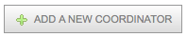

Course
The 7th tab is titled ‘course’. This refers to the specific courses that have been arranged. The table on this page gives information on the course type, venue it is being held at, and what date it is being held on, as well as other information.

The button pictured below can be found above the table. By clicking this you will be taken to a page where you are required to input the details of the new course. Once completed, by clicking on the ‘submit’ button, the new course will be registered in the table.

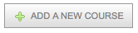

Change Password
The 8th button along the control panel is titled ‘change password. This tab, once clicked takes the user to a window that allows them to change the password to the database. Below is a picture of the ‘Change Password’ window.
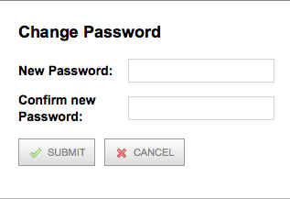

Action
The right-most header of each table contains the word ‘action’. This column consists of up to 4 buttons which when clicked on, carry out a specific action

Below is a picture of the action header, and the 4 buttons in its contents
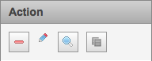

- Red line – the left icon is used to delete the row of information from the table
- The pencil – the middle left icon is used for copying the link to a ‘course booking’ page to your clipboard
- The Magnifying glass – the middle right icon is used to see further details of the course
- The 2 sheets of paper – the right icon is used for duplicating the row of information

Not all tables have all 4 buttons, as some don’t not require all the actions

Logging out
To log out of the database, click ‘logout’ coloured in red. This can be found at the top right hand side of each page you go on.

